VSCode Extensions List

- LiveServer is required for the week’s demos
  - Bolded extensions are strongly recommended!

-Live server (lets us right click an HTML file and open quickly “open with live server”)
-Intellicode (gives us predictive options while writing our files, like how IntelliJ does)
-vscode-icons (lets us see better icons in our vscode)
-Prettier (code formatter, makes your code look more sane)
-Auto Rename Tag (quality of life, automatically changes the other half of a tag you change)
-GitHub Copilot or any other integrated AI tool (There are free ones out there)
-Better comments (gives us more options on comments like TODOs, warnings, etc)
-HTML CSS support (id and class attribute completion)

What is HTML?

- HyperText Markup Language (HTML) is used to create webpages. HTML has been the standard for creating webpages since the mid 90s.
  - HTML is not a programming language. It’s a markup language! Markup languages (HTML, XML, etc.) are descriptive not programmatic.

- HTML is the face of your webpage. It creates what a web page looks like (along with CSS), whereas Javascript is what gives webpages functionality.
  - HTML = face (structure)
  - CSS = makeup (style)
  - JS = brain (logic – what makes everything work)

HTML Syntax is broken down into two subsets: elements and attributes.

1.) HTML Elements

● Elements provide the structure of the document and are defined by tags.
○ E.g. <div> this is a div element, surrounded by the div tag </div>
● HTML must have its tags properly nested to be valid.
○ Correct:
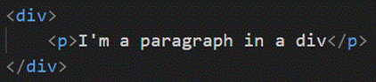
○ Incorrect:

There are two types of HTML elements:

- Block elements: These elements will render as a block on the page. In other words, block elements block an entire line on the page for themselves.

- Inline elements: These elements can sit next to each other on the same line when rendered. Can be rendered in the same line as each other.

● Common HTML elements (NOT a comprehensive list):
○ <div> defines a “division” of the page. Often contains other elements. (block)
○ <h1> through <h6> are header tags. 1 is the largest 6 is the smallest. (block)
○ <p> defines a paragraph, typical text elements (block)
○ <br> line break. Creates a new blank line (doesn’t need closing tag) (block)
○ <span> standard inline element, like an inline p (inline)
○ <img> displays an image (does not need closing tag) (inline)
○ <a> anchor tag used to make a hyperlink. (inline)

2.) HTML Attributes

- Attributes are metadata used to describe the elements; you can think of them as parameters defining the specific element tag.

- Attributes are defined within a tag of an element as a key/value pair.
  - For instance, in an image tag, the browser needs to know the location of the image: <img src=”www.myimage.com/puppy/”/>
    - src is the attribute in this case, telling the browser where to find the image

- Global attributes are those that can be applied to any tag. These will be very useful when we start messing with CSS. Some include:
○ class - you can group elements together under a class name
○ id - a good way to uniquely identify an element
○ hidden - used to hide an element
○ style - if you want to use inline styling (not best practice for CSS)
○ title - lets you add a text flag that appears when you scroll over an element

- div is the element
  - id and style are both attributes

HTML Doctype Declaration & Root Tag
- <!DOCTYPE html> ← This is the doctype declaration. It informs the browser what type of document we are displaying (HTML).
○ THIS IS NOT A TAG! It’s the doctype declaration. It’s its own thing.

- The root tag of an HTML document is <html>. All your HTML must go in between the opening and closing tags of this element.
  - The HTML page is then further divided into a <head> section, usually for metadata, and the <body> section for actual content to be displayed.

HTML Lists

- HTML has built-in functionality for displaying lists of items. There are two types of lists: Ordered and Unordered
  - Ordered lists have a progression such as 1 2 3… etc.
  - Unordered lists have no order. They are all represented by the same character - usually a bullet.

● Ordered lists use the <ol> tag
● Unordered lists use the <ul> tag.

- Items in both types of lists use the <li> tag (list item).
  - Note: Lists of either type can be nested inside other lists.

HTML Tables

- Tables are an easy way to structure our HTML pages and display information. There was a time when almost all HTML pages were just giant tables.

- To create a table, we begin with a <table> tag. Then…
● <thead> will define header rows
○ Inside that, we can have the <tr> which creates actual rows
■ <th> will then give the actual cell data for that header cell
● <tbody> defines the body of a table
○ Each row of the table will have a <tr> tag
■ Individual cells in the row will have a <td> tag
● <tfoot> can be used to add a footer element to your table.

HTML Input Types

- HTML has built-in elements to take in various types of input. Ingested input may be sent to some other app, or processed in the webpage’s code.

- Input elements include:
  - Text - general use text input
  - Password - prevents the inputs from being displayed on the screen.
  - Radio Buttons - select one from a list of options.
  - Checkboxes - select multiple from a list of options
  - Select Boxes - drop down menu to select an option
  - File select boxes - Allows you to upload a file from your local machine.
  - Text Area - A multi-line text field.
  - Reset and Submit buttons.
  - The <label> tag can be used to give a text label to an input field. It’s also helpful for extracting data from certain inputs like radio or checkbox.
Input boxes are often grouped within forms with “submit” buttons
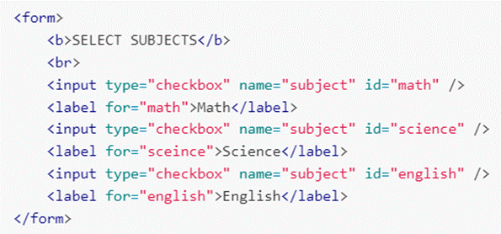
I don’t love traditional <forms> for full stack development; Feel free to try them, but they don’t always agree with the tools we’re using. Individual input boxes are plenty for your projects.

HTML 5 Specific Features

- HTML 5 introduced the DOCTYPE declaration.
  - Before 5, DOCTYPE behavior still existed but it was longer and uglier.

- Semantic tags - element tags that are descriptive of the tag’s intended use beyond just their functionality”. In other words, their names are self-explanatory
■ <article>
■ <header>
■ <footer>
■ <summary>
■ <section>
- These are good for society! They benefit accessibility features and are essential for screen readers for the visually impaired.
○ https://www.tutorialspoint.com/html5/html5_new_tags.htm

- HTML 5 also introduced elements to natively embed audio and video
  - <audio> lets you include audio files (mp3, wav)
  - <video> lets you include video files (mp4, webm)

